Reconnective Healing / Emotional Healing Questionnaire |  |  | How did you hear about us?
Name : Phone : Email :
Address : Emergency Contact & their relationsip to you:
DOB :  Age :  Current Weight :  Ideal Weight  Height: | What work do you do?  What are your Hobbies |  |  | Who do you live with?  Are you Married / Single / Partnered / Divorced / Widowed  Partner’s name & age:  Children:
Do you currently have a contagious condition / cough / respiratory illness / blood-borne virus? | Do you have a mental illness / issue? (eg OCD, bipolar, schizophrenia, depression, anxiety, suicidal) | Do you have any Addictions (eg: Sugar / drugs / alcohol / smoking / sex / gambling / gaming)
What brings you in for a session today? What are you wanting help with?

Current Medications, dose, when started (year), and what they are for. Include medications you take occasionally, and how often you take them in a month.

Current Supplements, brand, how long you have taken and what they are for?

Briefly, what is the story of your current issue/s? What is going on in your life right now? What recurring thoughts are occupying your mind most at present?

In order of priority, what are the top three things you want to achieve?

1.

2.

3.

What do you think are your present obstacles to health and happiness?

Do you have any diagnosed Medical Conditions?

Do you have any health concerns?

What Medications &/Recreatioal drugs do you take regularly or occasionally?

Are you under medical care?
Doctor / clinic details:
When was your last visit and what was it for?

What Supplements (& brand) do you take regularly or occasionally and what is it for?

What is going on in your life right now?

Do you have any pain? |  | What are your spiritual/religious beliefs?
Is there anything else we may need to know?

Current Health Overview: 10=high 5 = moderate 1 = low 0=nil
Please rate your: | 0-10 | Comments
Energy levels overall |  | Indicate if varies between morning, afternoon and evening
Stress levels overall
Level of Anxiety
Depression
Irritability / Frustration?
Teariness / Sensitivity?
Low mood
Memory recall
Rate your overall sense of Wellbeing
Rate your Weight?
Sugar cravings |  | High / moderate / low / non-existant
Rate your Skin
Histamine – itching, rashes, hives
Sinus problems (blocked, congested, Post nasal drip)
Ears – Ringing, itching, blocked, infection
Overall Digestive Function?
Bloating / distenston |  | Indicate frequency : a few times in a day / daily / every other day / weekly / other
Reflux / gastric burning sensation
Gut pain / nausea
Rate your Bowel function |  | Indicate : well formed & easy to pass / loose / diarrhoea / lots of wind / mucus / constipated / urgent / other:
How often do you have a bowel motion... |  | Frequency : a few times in a day / daily / every other day / weekly / other
Wind / flatulence. Is it Odorous?
Do you have any Haemorrhoids or blood on wiping?
SLEEP - Rate your sleep quality overall |  | (10=go to sleep easily, sleep through the night and wake well rested)
Average hours of sleep
How often do you wake at night? |  | What time/s do you wake? Time taken to go back to sleep -
Overnight trips to the loo (number)

Do you have any body pain or discomfort? Please rate where 1 = low / 10 = high.
Muscle tension / hardness / knots
Body pain
Headaches – frequency, intensity etc.
Neck & Upper Shoulders
Middle Back
Lower Back
Legs
Arms & shoulders
Joints
Legs
Feet
What exercise are you doing & how much? Rate the intensity MILD/MODERATE/HIGH

Women’s Health (As Appropriate)
HORMONES – overall sense of Hormone Balance? |  | Notes:
Any night sweats?
Libido overall? |  | High / moderate / low / non-existant
Menstrual pain
Breast Tenderness
Premenstrual Tension / Mood changes b4 pd
How long was your last cycle (first day of period to day before flow of next period) |  | Cycle length (days) : 21 / 28 / 30 / 40+ 1st day of last period – date :
Menopause / Perimenopause? |  | Year it started :
Do you lose bladder control when you sneeze?
When was your last pap smear & what was the result?
How many mamograms have you had? | Bone Denisty Tests?
In Pregnancy did you have any issues?
High blood pressure? Diabetes?

Men’s Health (As appropriate)
Has the strength of the urine stream changed?: |  | Has your ability to develop or maintain an erection changed?
Are you concerned about your prostate? |  | Are you concerned?

How is your body feeling?
Mark any areas of discomfort or issue, and rate out of 10, where 10 is strong / severe.
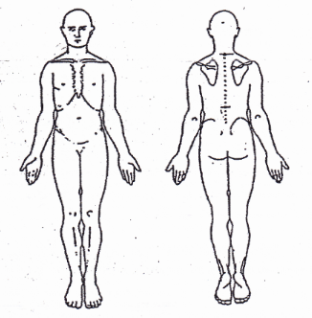

Current & Past Medical:
Are you currently under medical care?
Doctor / clinic details:

When was your last visit and what was it for?

Are you seeing any other practitioners? Who and what for?

Outline your Medical History : What have you been diagnosed with in your life – include year/s and treatment? | What Medications have you used in the past? (Include when, how long for and what for? Also include recreational drugs.)

Hosptialisations / Surgery –
What organs do you no longer have (tonsils, appendix, gallbladder …)? | Do you have a pacemaker?
Have you had a transplant? | Do you have any implants or prosthetics?
How many general anaesthetics have you had? | How many : Xrays MRIs CAT scans  What for?

Health History. Please indicate which of the following apply to you:

 |  |  | Parasites |  | Memory issues |  | Abnormal Pap Smear
 | Hayfever |  | History of gastro / Bali belly |  | Dizziness |  | Anaemia
 | Hives / Urticaria |  | Coeliac Disease |  | Tinnitis / Ringing in the ears |  | Ovarian Problems
 | Sinus issues |  | Irritable Bowel |  | Circulation Problems |  | Endometriosis
 | Herpes |  | Coronary Artery Disease |  | Cold hands / feet
 | Cold sores |  | Diverticular Disease |  | Parkinson’s Disease |  | Numbness
 | Glandular Fever (EBV/CMV) |  | Reflux |  | Dementia/Alzheimer’s |  | Ovarian cysts
 | Molluscum |  | Hiatal Hernia |  | Paralysis / parasthesia |  | Fibroids
 | Chicken pox |  | Stomach Ulcers |  | Abnormal Heart Valve/s |  | Thrush
 | Measles |  | Helicobacter |  | High Blood Pressure
 | Bronchitis |  | Gluten sensitivity |  | Tingling |  | Anxiety
 | Pneumonia |  | Dairy Sensitivity |  | Migraines |  | Panic attacks
 | Asthma |  | Colon or Rectal Polyps |  | Headaches |  | Depression
 | Shortness of breath |  | Gall Stones |  | Eczema |  | OCD
 | Chronic cough |  | Skin Tags |  | Psoriasis |  | Autism
 | Post Nasal Drip |  | Diabetes |  | High Cholesterol Level |  | Aspergers
 | COPD/Chronic Lung Dx |  | Cataracts |  | Cartoid artery obstruction |  | ADD / ADHD
 | Tuberculosis |  | Osteoarthritis |  | Blood Clots/DVT |  | Schizophrenia
 | Lung problems |  | Reumatoid arthritis |  | Stroke |  | Seizures / Epilepsy
 | Sleep Apnoea |  | Broken Bone/s |  | Hearing Loss |  | Pre-eclampsia
 | Burning tongue |  | Osteopenia |  | Stroke |  | Post Natal Depression
 | Burning skin |  | Osteoporosis |  | Irregular Heart Beats |  | Gestational Diabetes
 | Raynauds |  | Fatty Liver |  | Atrial Fibrillation |  | Cesarean
 | Wandering joint pain |  | Cirrhosis |  | Heart Failure |  | Stillbirth
 | Auto-immune disease |  | Hepatitis |  | IVF treatment
 | AIDS |  | Hemochromatiosis |  | Blighted Ovum
 | PANS / PANDAS |  | Glaucoma |  | Miscarriage/s
 | Cancer |  | Macular Degeneration |  | Grief
 | Mouldy environment |  | Prostate Issues |  | Smoking |  | Trauma
 | Asbestos contact |  | Kidney Disease |  | Parents smoked |  | Narcissistic Parent / sibling
 | Mercury amalgums |  | Gout |  | Farming history
 | Strep Thoat |  | Scars - internal
 | Golden staph |  | Scars - external
 | Shingles

VACCINES – what year/s and how many doses have you had of:
Flu injections | Pneumonia | Tetanus | Hepatitis | Yellow fever
MMR | Chicken Pox | Whooping cough | Tuberculosis (TB) – this would have left a scar on your shoulder.
HPV (Giardasil - Cervical Cancer vaccine) |  |  | Other:

Life Balance Assessment
Rate | WHEEL OF LIFE  Rate each area out of 10, where 10 is perfectly satisified. | 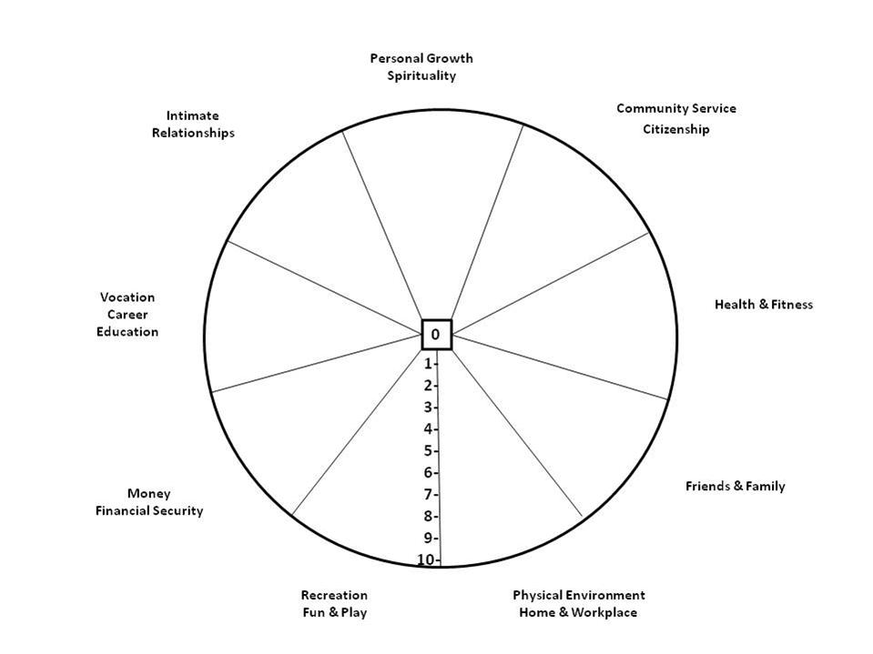
 | Personal Growth & Spirituality
 | Community, Service, Citizenship - Sharing in a community sense.
 | Health
 | Fitness
 | Friends
 | Family
 | Physical Environment - Workplace / School
 | Physical Environment – Home / Living zone
 | Recreation, Fun, Play
 | Money, Financial Security
 | Vocation, career, education
 | Intimate relationships
 | Sense of Self, confidence, personal respect
 | Other area/s of importance to you :

How do you think this work will make you feel in your body / life / experience?

Please read, sign and return before your session :
Session Information - It is important to understand that this session is not intended to diagnose or treat any medical, mental or physical condition. This session is simply an infusion of the Reconnective Healing energies for your body to utilise in its innate wisdom. We offer no promises or claims about what will happen during or after your session. We do not intend or promise any medically therapeutic results, as we cannot gauge how your body will use this energy. Consider this session to be similar to a meditation that you are engaging in during the time you are on the table.
Most people feel the sensations of tingling, warmth, pressure, twitching and more, some people don’t feel anything other than a lovely feeling of relaxation. To understand this energy, it helps to have watched some of the videos put out on Reconnective Healing.
It is best to have no expectations, no judgements, no preconceived ideas and no agenda when you receive this session. Open your heart and open your mind, be in a state of reception, and let go of everything else. Let go of your body as well. Sometimes the body moves during the sesion, just allow it. Sometimes your tummy can make noises as the energy begins to flow, just allow it. Notice what you notice, yet don’t hold on to anything.
If you need anything during your session, please ask. This is your session and it is important that you are comfortable. If lying down isn’t comfortable we can do the session sitting up, lying face up, or lying face down, whichever you prefer.
DISCLAIMER - Any information, data, documents, guidelines, images or general material is for general information only, and is not intended to be prescriptive or diagnostic, simply informative. I understand the above and will remain in full responsibility for myself, my actions and decisions.
All information provided is true and correct.
Date : Name : Sign :

